Spring Boot Rest: -

HTTP Request Methods:

GET: -

@GetMapping("/URL") @RequestMapping(value="/URL",method=RequestMethod.GET)

If request type is GET, It’s never support body.

Here GET is used to getting data from server

Get is never sending data to DB

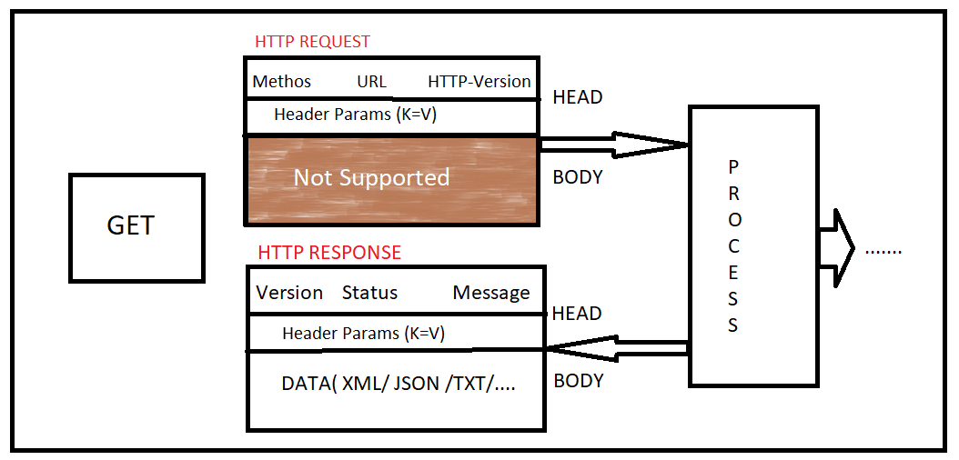

Query Param:-

Let us Assume we have DB, In that DB WE have so many Id’ number,

Here I am asking give me (GET) a ID=10 at sever not an body, (it’s never going to store in data base)

Redirect:PATH:-

@RequestMapping("/remove")

public String delete(){

//3LOC

return "redirect:all";

}

HTTP Servlet:-

To access any object, created by Servlet container, want to use in our controller, then use either as HAS-A variable or as Method param.

@RequestMapping

public String show(HttpServletRequest req) //using method param

{

System.out.println("FROM METHOD");

return "EmpHome";

}

MULTIPLE Methods:-

@RequestMapping(value = "/home",

method = {

RequestMethod.GET,

RequestMethod.POST

})

public String showLogin() {

return "HomePage";

}

MULTIPLE PATHS:-

-> For one method we can provide multiple PATHs as array type { URL,URL,URL,URL,... }

\*\*\* All given Paths comes under only one method Type.

Ex: /login, /home, /logout --> LoginPage

@Controller

public class HomeController {

//@RequestMapping(value={ "/login", "/home", "/logout" })

@RequestMapping({

"/login",

"/home",

"/logout"

})

public String showLogin() {

return "LoginPage";

}

}

Example:-

@Controller

//@RequestMapping("/") --> VAILD

public class AdminController {

//@RequestMapping -->VAILD

@RequestMapping("/")

public String showHome() {

return "WelcomePage";

}

}

ResponseEntity<T>():-

It used for SpringBootRest for response with status code and message.

We can give T->String,Map,Object …. Type of data is possible

@RequestBody:-

Get will not support above annotation because Body in not there in GET.

@ResponseBody:-

It is by default response is JSON Format.

Content Negotiations:-

Accept: